Analysis & Design of Algorithms
LAB Assignment – 3
Name – Priyanshu Kumar Singh
Roll No. - 2401010174
Course – B.Tech CSE Core
Section – C

Task 1: To represent a graph using Adjacency List and Adjacency Matrix..
Solution :-

import networkx as nx
import matplotlib.pyplot as plt

# 🔹 Adjacency List
graph = {
0: [1, 2],
1: [2],
2: [3],
3: []
}

print("Adjacency List:")
print(graph)

# 🔹 Adjacency Matrix
matrix = [
[0,1,1,0],
[0,0,1,0],
[0,0,0,1],
[0,0,0,0]
]

print("\nAdjacency Matrix:")
for row in matrix:
print(row)

# 🔹 Graph Visualization
G = nx.DiGraph()

for node in graph:
for neighbor in graph[node]:
G.add_edge(node, neighbor)

plt.figure()
pos = nx.spring_layout(G)

nx.draw(G, pos, with_labels=True)
plt.title("Graph Representation")

plt.show()
Graph:
Adjacency List: {0: [1, 2], 1: [2], 2: [3], 3: []}

Adjacency Matrix:
[0, 1, 1, 0]
[0, 0, 1, 0]
[0, 0, 0, 1]
[0, 0, 0, 0]
Graph:

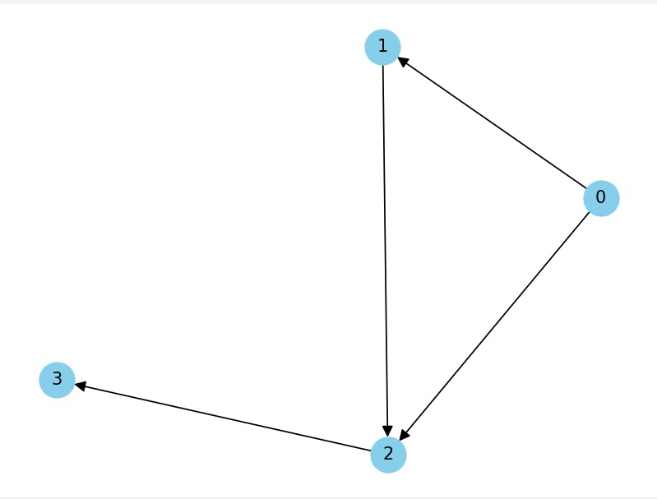

Task 2: BFS and DFS:
Aim:
To traverse a graph using Breadth First Search (BFS) and Depth First Search (DFS

Solution :-
from collections import deque
import networkx as nx
import matplotlib.pyplot as plt

# 🔹 Graph
graph = {
0: [1, 2],
1: [2],
2: [3],
3: []
}

# 🔹 BFS
def bfs(graph, start):
visited = set()
queue = deque([start])
result = []

while queue:
node = queue.popleft()
if node not in visited:
visited.add(node)
result.append(node)
queue.extend(graph[node])

return result

print("BFS:", bfs(graph, 0))

# 🔹 DFS
def dfs(graph, node, visited=None):
if visited is None:
visited = set()

visited.add(node)
result = [node]

for neighbor in graph[node]:
if neighbor not in visited:
result.extend(dfs(graph, neighbor, visited))

return result

print("DFS:", dfs(graph, 0))

# 🔹 Graph Visualization
G = nx.DiGraph()

for u in graph:
for v in graph[u]:
G.add_edge(u, v)

plt.figure()
pos = nx.spring_layout(G)

nx.draw(G, pos, with_labels=True)
plt.title("BFS & DFS Graph")

plt.show()
output: BFS: [0, 1, 2, 3]
DFS: [0, 1, 2, 3]
Graph:

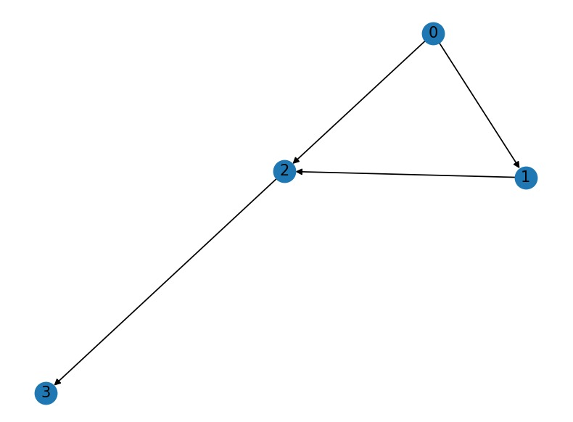

Task 3: Topological Sorting:
Aim:
To perform Topological Sorting on a directed acyclic graph (DAG).
Solution :-
import networkx as nx
import matplotlib.pyplot as plt

# Graph definition
graph = {
'A': ['C'],
'B': ['C', 'D'],
'C': ['E'],
'D': ['F'],
'E': ['H', 'F'],
'F': ['G'],
'G': [],
'H': []
}

# Create directed graph
G = nx.DiGraph()

# Add edges
for node in graph:
for neighbor in graph[node]:
G.add_edge(node, neighbor)

# Draw graph
plt.figure()
pos = nx.spring_layout(G) # layout
nx.draw(G, pos, with_labels=True)
nx.draw_networkx_edge_labels(G, pos)

plt.title("Graph Visualization (Topological Sort)")
plt.show()
output:
Topological Sort: ['B', 'D', 'A', 'C', 'E', 'F', 'G', 'H']
Graph:

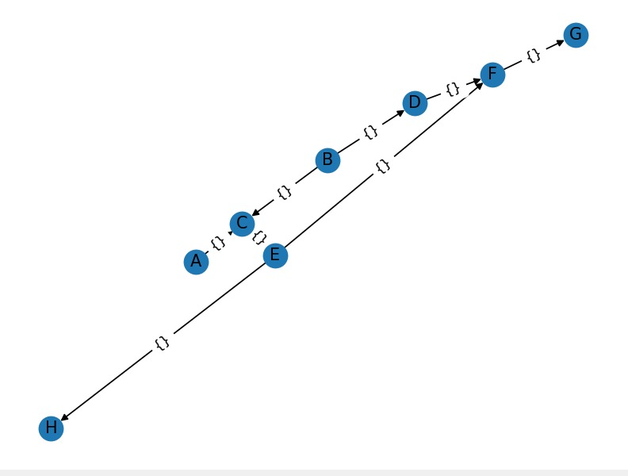
Task 4: Shortest Path Algorithms
Aim: To find shortest paths using Dijkstra and Bellman-Ford algorithms.
Solution :-
import networkx as nx
import matplotlib.pyplot as plt
import heapq

# Weighted Graph (same for both)
graph_weighted = {
0: [(1,4), (2,1)],
1: [(3,1)],
2: [(1,2), (3,5)],
3: []
}

# Convert to edge list for Bellman-Ford
edges = []
for u in graph_weighted:
for v, w in graph_weighted[u]:
edges.append((u, v, w))

# 🔹 Dijkstra
def dijkstra(graph, start):
pq = [(0, start)]
dist = {node: float('inf') for node in graph}
dist[start] = 0

while pq:
d, node = heapq.heappop(pq)

for neighbor, weight in graph[node]:
if dist[neighbor] > d + weight:
dist[neighbor] = d + weight
heapq.heappush(pq, (dist[neighbor], neighbor))

return dist

# 🔹 Bellman-Ford
def bellman_ford(edges, V, src):
dist = [float('inf')] * V
dist[src] = 0

for _ in range(V-1):
for u, v, w in edges:
if dist[u] != float('inf') and dist[u] + w < dist[v]:
dist[v] = dist[u] + w

return dist

# Run Algorithms
print("Dijkstra:", dijkstra(graph_weighted, 0))
print("Bellman-Ford:", bellman_ford(edges, 4, 0))

# 🔹 Graph Visualization
G = nx.DiGraph()

for u, v, w in edges:
G.add_edge(u, v, weight=w)

plt.figure()
pos = nx.spring_layout(G)

nx.draw(G, pos, with_labels=True)
labels = nx.get_edge_attributes(G, 'weight')
nx.draw_networkx_edge_labels(G, pos, edge_labels=labels)

plt.title("Shortest Path Graph (Dijkstra & Bellman-Ford)")
plt.show()
output:
Dijkstra: {0: 0, 1: 3, 2: 1, 3: 4}
Bellman-Ford: [0, 3, 1, 4]
Graph:
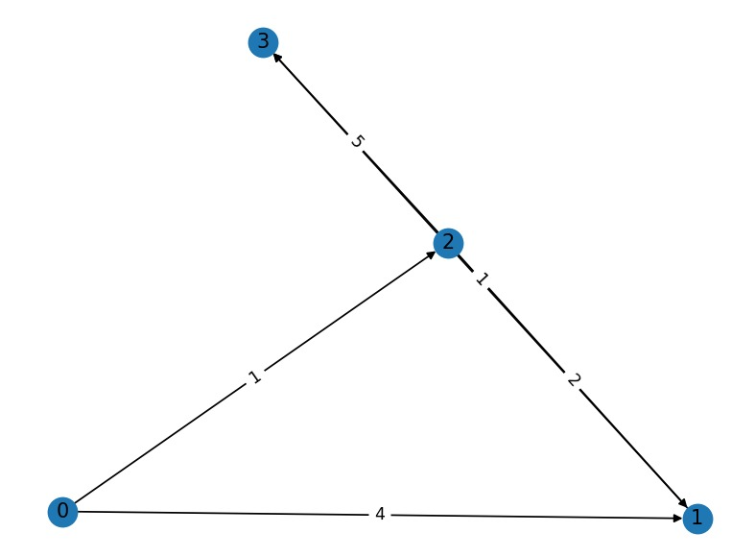
Task 5: Minimum Spanning Tree (Kruskal)
Aim: To find MST using Kruskal’s Algorithm.
Solution:
import networkx as nx
import matplotlib.pyplot as plt

# 🔹 Kruskal Functions
def find(parent, i):
if parent[i] != i:
parent[i] = find(parent, parent[i])
return parent[i]

def union(parent, rank, x, y):
rootX = find(parent, x)
rootY = find(parent, y)

if rank[rootX] < rank[rootY]:
parent[rootX] = rootY
elif rank[rootX] > rank[rootY]:
parent[rootY] = rootX
else:
parent[rootY] = rootX
rank[rootX] += 1

def kruskal(edges, V):
edges = sorted(edges, key=lambda x: x[2])
parent = list(range(V))
rank = [0]*V

mst = []

for u, v, w in edges:
if find(parent, u) != find(parent, v):
mst.append((u, v, w))
union(parent, rank, u, v)

return mst

# 🔹 Input Graph
edges = [
(0, 1, 10),
(0, 2, 6),
(0, 3, 5),
(1, 3, 15),
(2, 3, 4)
]

V = 4

# Run Kruskal
mst = kruskal(edges, V)
print("Minimum Spanning Tree:", mst)

# 🔹 Create Graph
G = nx.Graph()

for u, v, w in edges:
G.add_edge(u, v, weight=w)

# 🔹 Draw Graph
plt.figure()
pos = nx.spring_layout(G)

nx.draw(G, pos, with_labels=True)
labels = nx.get_edge_attributes(G, 'weight')
nx.draw_networkx_edge_labels(G, pos, edge_labels=labels)

plt.title("Original Graph")
plt.show()

# 🔹 Draw MST separately
G_mst = nx.Graph()

for u, v, w in mst:
G_mst.add_edge(u, v, weight=w)

plt.figure()
pos = nx.spring_layout(G_mst)

nx.draw(G_mst, pos, with_labels=True)
labels = nx.get_edge_attributes(G_mst, 'weight')
nx.draw_networkx_edge_labels(G_mst, pos, edge_labels=labels)

plt.title("Minimum Spanning Tree (Kruskal)")
plt.show()
output:
MST: [(2, 3, 4), (0, 3, 5), (0, 1, 10)]
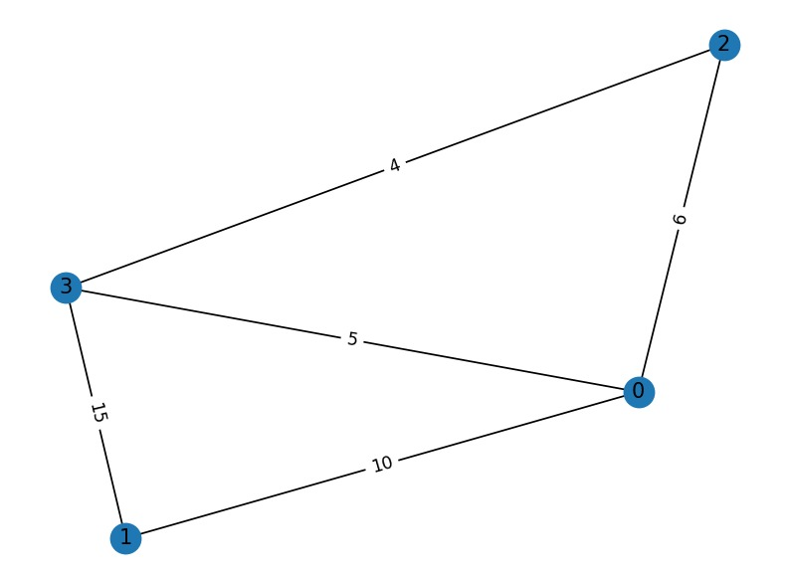
Github link:

